Importing LCD searches into EMIS
Save the search file from the Momenta website or from the e-mail that has been sent you.
Name your folder LCD and click OK.
Go to EMIS>Reporting>Population Reporting and then Select Add>Folder.
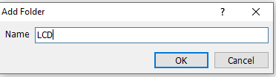
Click Import.
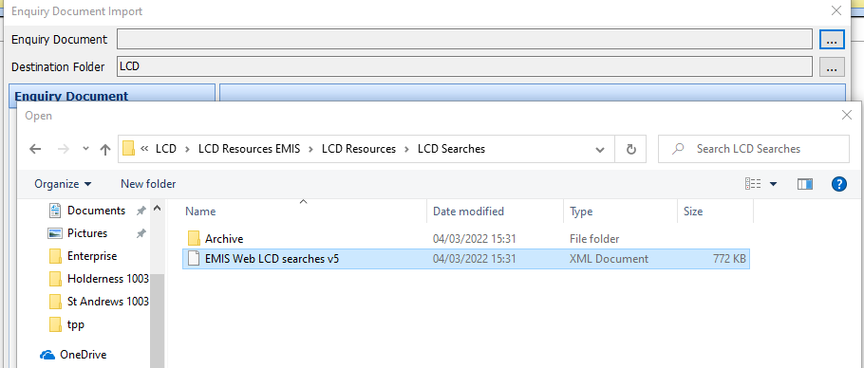
Click on the three dots beside Enquiry Document and then find and select the search file you saved earlier.
The top two searches beginning with the $ symbol will identify your eligible patients either with or without a mobile phone number recorded in their record.
