Accessing the LCD Searches
Go to Reporting>Clinical Reporting and in the CDRC Quality folder select Diabetes IGR.
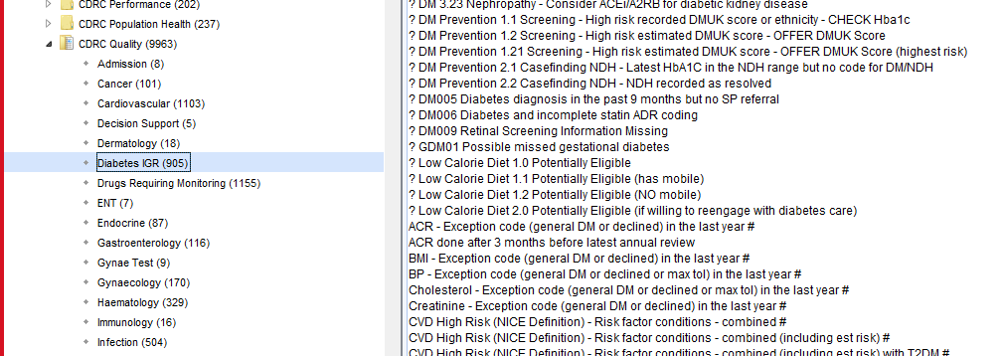
The ?Low Calorie Diet Potentially Eligible searches will identify the eligible patients. Search 1.1 will display those who have a mobile phone number recorded, search 1.2 will identify those without.

Accessing the LCD documents
The invitation letters can be found in the CDRC folder in the Invitation section.
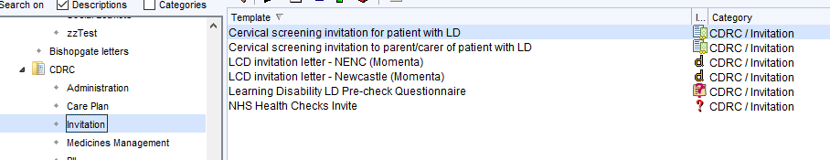

The referral form can be found in the CDRC Referral Proformas folder in the Diabetes section.
