Importing documents into EMIS
Save the document files for the invitation letter and referral form that you have been e-mailed or downloaded from the project website.
Go to the Document templates section of Resource Publisher. Click on Add and then Folder.
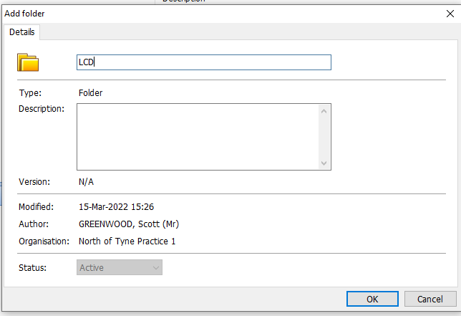
Click Import and then select Document.
Name your folder LCD and click OK.
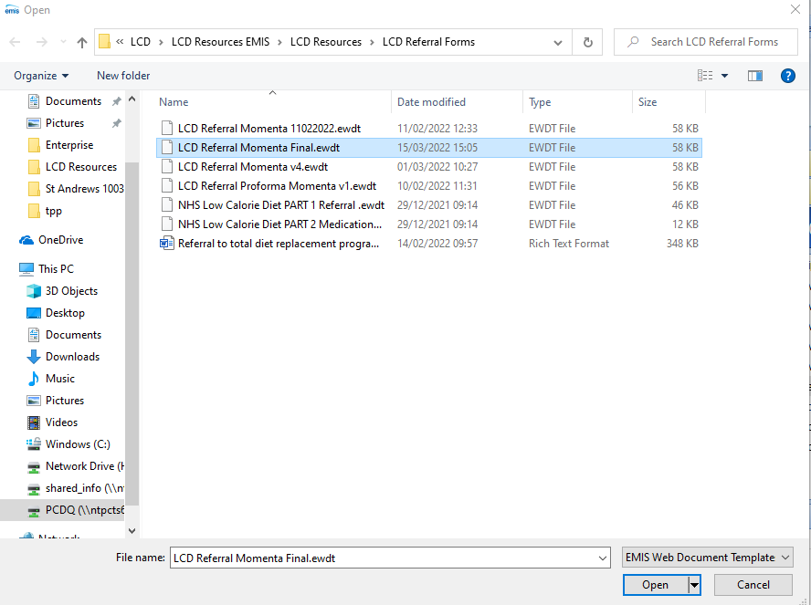
Repeat this process for the invitation letter document.
Select the Referral form document you saved earlier.

